Project 2 Proposal
Exploring the Relationship Between Weather and Formula 1 Driver’s Performance
Team Members: Akin Akinlabi, Gia Nguyen, Cat Weiss
Section-Team: Professor Gunnar Kleeman Section 9 – Team 3
Repo Link: https://github.com/UC-Berkeley-I-School/Project2_Akinlabi_Weiss_Nguyen
Datasets:
- Weather API: https://open-meteo.com/en/docs/historical-weather-api
- Formula 1 Dataset: http://ergast.com/mrd/db/
Dataset Description: The Formula 1 dataset will be compiled using numerous datasets in the Ergast API and will be named as our “Race Dataset”. The weather API will fetch the weather conditions on the day and location of the races based on the “Race Dataset.” The results from the weather API will be named as our “Weather Dataset.” These two datasets will be joined together to create a master dataset where we will be doing our exploration on the impact of weather conditions on driver position in each Formula 1 race from 2018-2022.
Race Dataset Preview
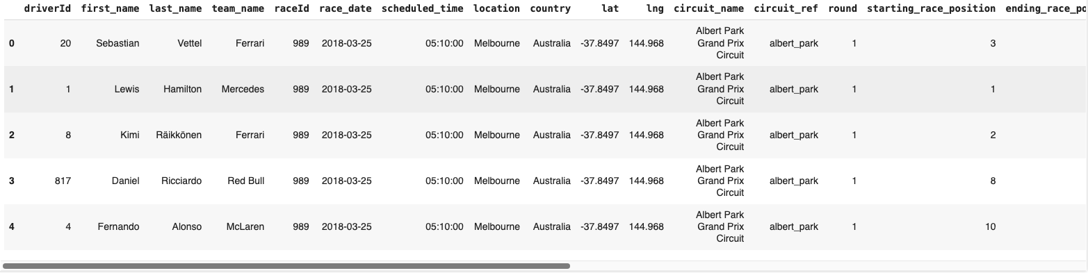
Weather Dataset Preview
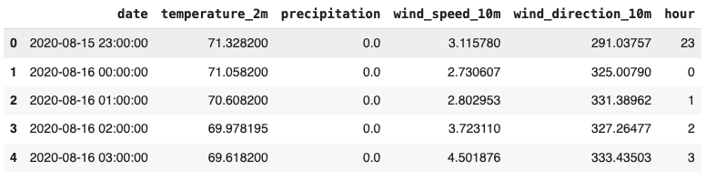
If applicable, we will be adding each team’s cost and revenue from 2018-2022 as part of the analysis to see if there is a correlation between weather and cost/revenue.
Dataset Structure:
Race Dataset Weather Dataset
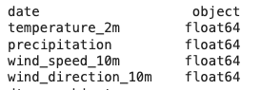
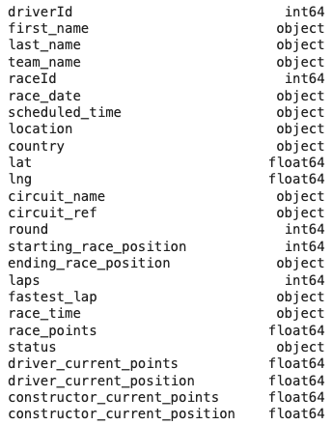
Questions:
- How do abnormal weather conditions affect the role it plays in driver position by the end of each year from 2018-2022?
  - We define abnormal weather conditions as when it is windy, raining, or the temperature is either very hot or cold
  - We benchmark drivers in comparison to their teammates in all abnormal conditions except for rain where we can benchmark all drivers
- Are there certain drivers that perform better in different weather conditions?
- What are the trends we see in driver’s performance for different weather conditions?

Supplemental Data Sources for Reference:
- Medium article for F1 analysis: https://luke-beggs.medium.com/visualising-f1-performance-and-budget-f7ad71460ec
- Sportico Article: https://www.sportico.com/feature/formula-1-team-value-rankings-1234727512/

- F1 Teams’ Revenue 2017-2021: https://www.statista.com/statistics/1137226/formula-one-revenue/

Planned Final Report Structure:
- Introduction & brief background about the topic
- Exploratory Data Analysis:
  - Examine what are the most frequent weather conditions on race day
  - Examine which drivers perform the best in given weather conditions
  - Examine the relationship between weather and performance
  - Examine the team’s overall performance based on their driver’s performance
  - Identify if there are certain vehicle types that are more suitable for certain weather conditions
- Conclusion

Initial Plots, Figures, or Tables:

